Fraud Detection (Anomaly Detection)

Introduction
Anomaly detection is a method for identifying unforeseen piece or event in the dataset, which differ from the norm. As Vedant (2018) mention in his blog that “Anomalies are the unexpected behaviour in the observed world”, the main goal of fraud detection is to pickout the unexpected behaviour that do not adhere to the normal patterns which is also known as a normal behaviour. Over the years, fraud has been considered as one of major issue in the different sectors like banking, medical, insurance and many others. Due to the increase in digitzation across the world, fradulent activities have also incerased. Moreover, fradusters have become more skilled in identifying the loopholes in the system where they can loot more, this has become a more challenging task to make a secure system for authentication and preventing the business form fraud, in this case fraud detection algorithms plays a vital role on preventing frauds.
For fraud detection algorithm ml is used explicitly which helps in solving the real-world problems. Ml is way better than humans at processing large amount of datasets, using computing power it can detect and recognize thousands of patterns, which provide a better way for detecting unusual behaviour in the datasets.

Machine Learning
In ml,modeling of an algorithm starts with gathering and segmenting the data, then the data is fetch into the ml algorithm model as a training set to predict the probability.
The complete process of the ml can be viewed with the below pasted image.
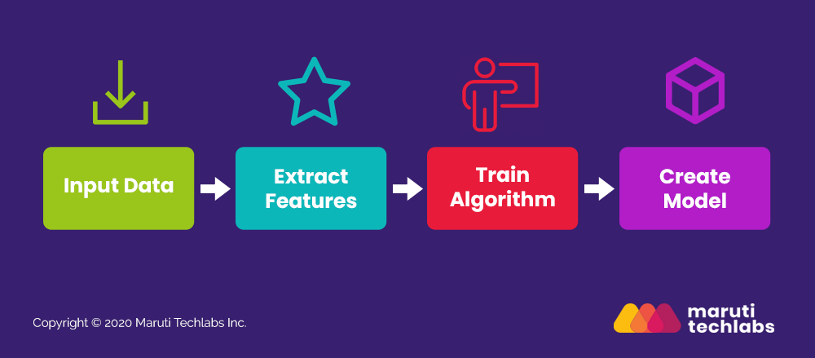

Ref:https://marutitech.com/machine-learning-fraud-detection/

let’s dig bit deeper the whole process of machine learnig.
- Input Data - Sufficient amount of data should be provided to the ml model, so that it can capture all the noise in that data. If large amount of data is fetch into the model, this will help the model to learn about the different patterns which is present in the data and through that ml model will be able to make better predections or it will be able to differenciate the normal and abnormal activity. (Note: in our case we will fetch our merchant data to depict the abnormal behaviour)
- Extract Features – Features extraction basically works on extracting the information of each and every thread associated with the data. Features means column names in the data set. Features will help to determine the signals which will help in identifying the frauds.
Some of the features through which fraudster can de identified are
  - Identity of the customer (i.e. Cust Id, Email address, Credit card no)
Note: In our case the features name may vary (eg. Any unique merchant details)
  - The past order details.
Note: In our case we can take merchant offer posting details
  - Customer Location (IP Address, Location)
- Training Algorithm: In this process with the sufficient amount of data, we need to help the machines to understand the difference between normal and abnormal behaviour. In order to make machine to understand this patterns, we need to create an algorithm, train it using learning data set and help models to make accurate predictions.
- Create Model – The training set will help the model to understand and comprehend the algorithm defined. When the training of an ml model is done with the training data set, now we can fetch the test data to find the accuracy of the predections. If the trained model gives the better accuracy with the test data, then the model will be deployed with the live data and it will start predecting all the possible outcomes. The model will need to improvised whenever new data or new features is added to the system.
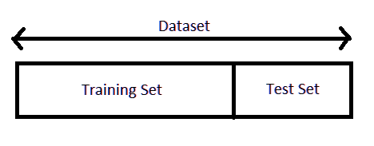

Ref:https://data-flair.training/blogs/train-test-set-in-python-ml/

What is Anomaly Detection?
Anomaly detection is nothing but a technique which identify a rare events or abnormal behaviour. This events or observations can be caused of suspicious activity. Because these events has some different patterns and are statistically differ from the rest of the data.

Types of Anomaly Detection
In general anomaly detection can be divided into three categories:
- Point Anomaly – An individual data instance in a dataset is consider to be a point anomaly if it belongs to far away from the rest of the data.
Example: Sudden transction of huge amount from a credict card.
Note: In our case suddenly merchant posting high %offers suddenly, suddenly posting n numbers of offers, etc..
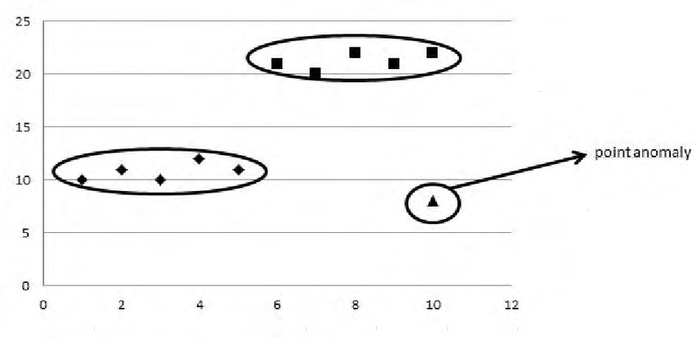

Ref:https://www.researchgate.net/figure/An-example-of-a-point-anomaly_fig1_270274504
- Contextual Anomaly: If a particular observation is anomalous from the other data points then this is called a contextual anomaly, or if the data is an anomaly because of the context of the observation.

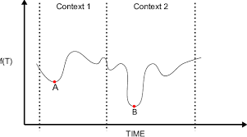
Ref:https://www.researchgate.net/figure/A-simple-example-of-contextual-anomalies-on-f-T-Here-anomalies-are-defined-as-the_fig2_260738754

- Collective Anomaly: Collective anomaly are known as a set of data instances that help in finding anomaly. This type of anomaly has teo variations.
  - Events are in unexpected orders.
  - Unexpected value combinations.
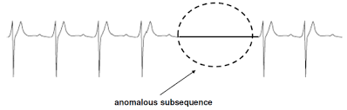
Ref:https://www.vdu.lt/cris/bitstream/20.500.12259/92994/4/Aleksas_Pantechovskis_md.pdf

Machine Learning Methods to do Anomaly Detection
There are two types of approach for detecting the anomaly in the data, they are,
- Supervised Learning
- Unsupervised Learning

Supervised Learning
In this method the data set has labeled features (column names) and target (result), example of features and target can be viewed below.
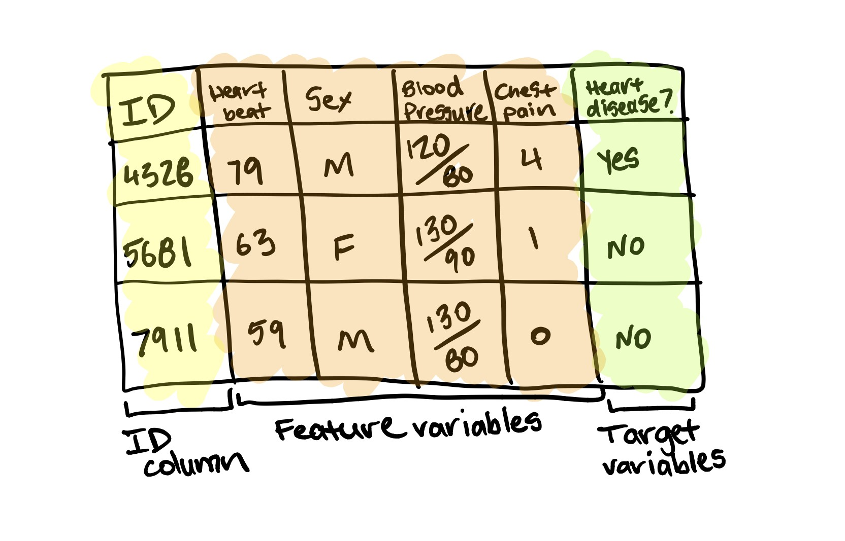

Ref:https://www.vdu.lt/cris/bitstream/20.500.12259/92994/4/Aleksas_Pantechovskis_md.pdf

In supervised learning method the trainig data is labeled with “nominal” or “anomaly”. This supervised setting is a ideal setting,it is the instance when a dataset comes neately prepared from the data scientist with all the data points labeled as nominal or anomaly.
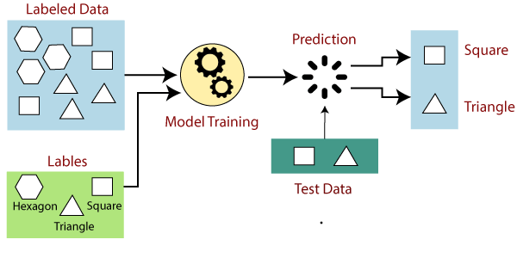
Ref: https://www.javatpoint.com/supervised-machine-learning
Note: if the target vales (i.e. result) in the data set has categorical data (e.g. Yes/No, Male/Female) then in ml it will be considered as a classification problem. If the target value has continious data or nominal data then in ml it is consider as a regression problem
from that neat and clean data. Different ml models can be trained and once the training is done with the sufficient amount of data (normally 80% of data is use for training purpose from the whole data set). The different models are tested with remaining 20% data, which is also known as test data. From that predections, the accuracy level of the different models is measured, model with the high accuracy will be select and it will be deployed in the process.
Few of the most commonly used ml models on detecting the anomalies under the supervised learning are,
- Logistic Regression
- K-Nearest Neighbour
- Support Vector Mechanism
- Naive Bayes
- Decision Tree Classification
- Ensemble Methods for Classification
  - Random Forest Classification
  - Gradient Boosting Classification

This model are measured by accuracy level and there are few commonly used methods to measure the accuracy levels are,
- Confusion Matrix
- F-1 Score

Unsupervised Learning

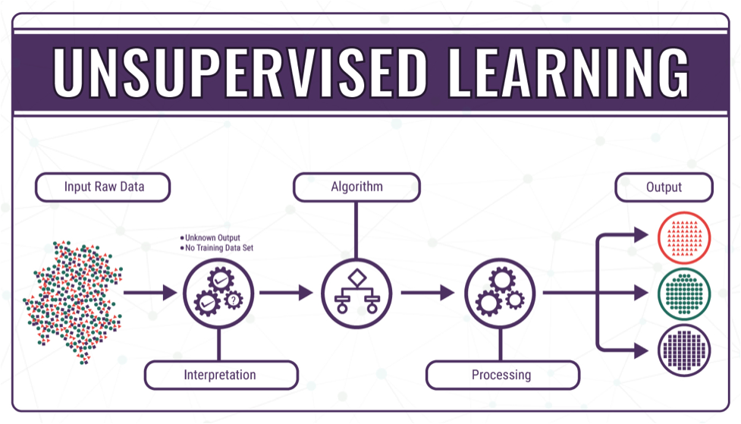
In unsupervised settings the training data is unlabeled and consist of “nominal” and “anomaly” points ( unlabeled means there will be column names but there will not be any target values i.e. result). The hardest case, and ever-increasing case for modelers in the ever-increasing amounts of dark data, is the unsupervised instance. The datasets in the unsupervised case do not have their parts labeled as nominal or anomalous. There is no ground truth from which to expect the outcome to be. The model must show the modeler what is anomalous and what is nominal. In the Unsupervised setting, a different set of tools are needed to create order in the unstructured data. In unstructured data, the primary goal is to create clusters out of the data, then find the few groups that don’t belong. Really, all anomaly detection algorithms are some form of approximate density estimate.
Ref: https://technative.io/why-unsupervised-machine-learning-is-the-future-of-cybersecurity/
Few popular ml models which is expicitly used for unstructured data are:
- Self-Organizing Maps (SOM)
- K-means
- C-means
- Expectation-Maximization Meta-Algorithm (EM)
- Adaptive Resonance Theory (ART)
- One- Class Vector Machine

Note: In our case in most of our business case we are going to get unstructured data and to detect anomalies from those unstructured data, we have to use unsupervised learning method.

